Instructions for usage (Please DO NOT copy these instructions into your email to clients):
The following copy has been approved by compliance. Please add your logo and contact information and use with approved letterhead or email signature to include required broker-dealer disclosures. However, any changes beyond that to the body content require additional compliance approval before sending. If you have no changes, please submit a final copy to compliance within five days of distribution. Please retain final documents for recordkeeping purposes and to ensure accuracy of disclosure and content distributed to the public.

Email Subject: Client Appreciation Event – Planning for 2024




2024 Market Outlook  Tuesday, December 5  12:00 p.m. ET (Live)  7:00 p.m. ET (Replay)  When making financial decisions, having access to reliable and unbiased information is essential. That’s why it’s important to find objective market analysis you can trust. The ongoing market disruptions have served as a reminder of the critical role financial planning plays in safeguarding your financial future.  At our upcoming Client Appreciation Event, we’ll host Dr. Charles Lieberman with Advisors Capital Management, an experienced analyst, to share his insights. Plan to join us as Dr. Lieberman analyzes the economic developments of the past year, demystifies the current challenges influencing the markets and helps you prepare for 2024. | Sponsored by  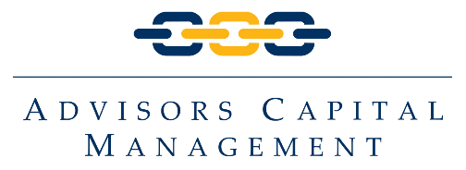  

Register now to join us and better understand how the following factors may impact your finances:  - Federal Reserve interest rate policy  - Inflation  - Geopolitics  - The 2024 general election | Dr. Charles Lieberman  Co-Founder, Chief Investment Officer  Advisors Capital Management
  Click here to RSVP

Best regards,

[INSERT YOUR NAME HERE]
[Company Name Here]
[Title Here]
[Broker-Dealer Name Here]

